CYMBUILD 26.3 | TECHNICAL DESIGN AND OPERATING MODEL
Schema and Metadata
Migration Automation
Purpose, architecture, operator workflows and future CI/CD delivery model

Document status: Target design with transitional current-state guidance
Version: 1.1
Prepared for: CymBuild engineering, release management and platform operations
Date: 8 September 2026
Primary scope: Schema migration, metadata migration and onboarding promotion

Document position: This document defines the intended end state. The current UI and controlled runner are transitional implementation mechanisms and remain under end-to-end hardening until fresh DEV-to-QA and QA-to-UAT promotions pass.

Contents
• 1. Executive summary
• 2. Purpose, outcomes and scope
• 3. Governing architecture and authority
• 4. Core release concepts
• 5. Schema migration design and UI process
• 6. Metadata migration design and UI process
• 7. UAT-to-LIVE onboarding model
• 8. Package integrity, idempotency and audit
• 9. Environment controls and security
• 10. Failure handling and recovery
• 11. Future CI/CD pipeline
• 12. Current versus target responsibilities
• 13. Operating procedures
• 14. Acceptance criteria and roadmap
• Appendix A. PowerShell runner reference
• Appendix B. Evidence and audit artefacts

How to use this document
Engineering teams should use Sections 3-10 as the implementation contract. Release managers should use Sections 5-7 and 13 as the operating procedure. Platform teams should use Sections 8-12 as the basis for Bitbucket Pipelines, immutable container promotion and Rancher-managed RKE2 deployment Jobs.

1. Executive summary
CymBuild requires database changes to move through DEV, QA, UAT and LIVE with the same control, traceability and repeatability as application binaries. The migration capability exists to remove environment-by-environment scripting, direct database editing and unrepeatable operator knowledge from releases.
The target model is build once and promote unchanged. Developers author canonical SQL and metadata manifests in source control. A release package is generated once from the DEV-authoritative state, validated against a disposable database, sealed with hashes, and then applied without regeneration to every later environment. Each target records the package identity, version, checksum, execution attempt and verification outcome.
Core outcome: QA, UAT and LIVE receive the identical reviewed package. Environment promotion never treats a later database as the new source of schema truth.

2. Purpose, outcomes and scope

2.1 Purpose
• Provide a controlled, repeatable and auditable path for schema and metadata change.
• Allow developers to review and configure release content in a UI while keeping execution outside the browser.
• Enable future unattended CI/CD execution with explicit approvals for protected environments.
• Detect source drift, target drift, stale generated files, invalid metadata identity and incomplete deployment.
• Restore database lifecycle state safely when preparation or deployment fails.

2.2 In scope
Area | Included capability
Schema | Tables, columns, indexes, constraints and programmable objects represented by reviewed source-controlled SQL.
Metadata | Run-based comparison, stable-GUID identity mapping, selection, validation, preview, idempotent apply and verification.
Lifecycle | Pre-deployment preparation, schema-binding restoration, generated record-history trigger restoration and evidence capture.
Automation | Command-line runner today; pipeline Jobs, package sealing and immutable promotion in the target state.
Audit | Run, selection, approval, release reference, package hash, execution attempt, outcome and verification evidence.

2.3 Explicitly out of scope
• Using a dbForge comparison script as the production deployment package.
• Manual database promotion or manual metadata updates in QA, UAT or LIVE.
• Automatic destructive cleanup of legacy duplicate data.
• Silently deploying only the supported subset of an accepted plan.
• Using QA or UAT as schema authority because an earlier environment happens to contain a change.

3. Governing architecture and authority

3.1 Application call path
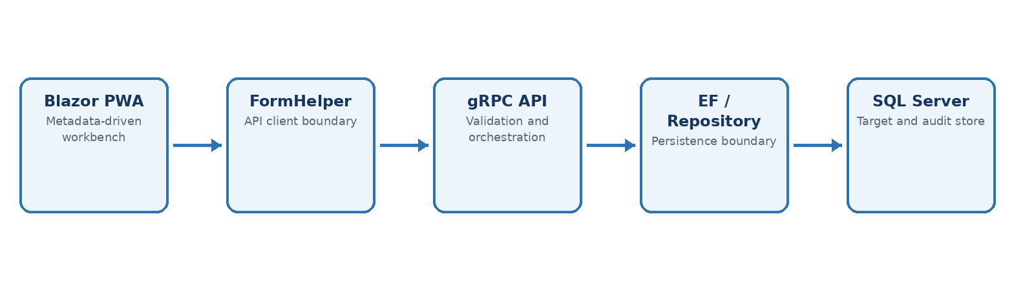
Figure 1. Mandatory application boundary for migration workbench operations.
The browser configures and displays migration work. It never connects to SQL Server and never executes deployment SQL. UI actions travel through FormHelper/API Client, the gRPC API coordinates validation, EF or repositories perform persistence, and SQL Server stores controlled migration state and audit evidence.

3.2 Authority model
Concern | Authoritative source | Not authoritative
Application code | Reviewed Git commit and immutable image digest | A running server or locally rebuilt binary
Schema | Canonical SQL in Database/CymBuild_DB/Schema | QA, UAT, LIVE or captured ad hoc DDL
Metadata | Stable-GUID source manifests and accepted release package | Environment-specific numeric IDs or direct table edits
Selection | Persisted, explicit selection for the release run | Unsaved checkboxes or an implicit “all differences” default
Release | Sealed package hash and release reference | A mutable folder of scripts
Current state | Latest recorded transition/audit record | Direct status-column manipulation

3.3 Non-negotiable domain rules
• Every new entity must atomically receive its SCore.DataObjects row with EntityTypeId.
• Workflow status changes use SCore.DataObjectTransitionUpsert; the latest transition is the current state.
• SQL uses explicit column lists, schema-qualified object names, idempotent patterns and transactions with TRY/CATCH where appropriate.
• Active-row logic normally uses RowStatus NOT IN (0,254).
• Integration side effects use SCore.IntegrationOutbox and an idempotency key.

4. Core release concepts
Concept | Meaning
Run | An auditable comparison and review context with source, target, saved selection, validation and status.
Comparison row | One schema object or metadata record difference with identity, hashes, difference type and risk.
Explicit selection | Only rows deliberately saved for the run are eligible for validation or deployment.
Canonical source | The reviewed Git file that will be placed in the package; captured database DDL is never executed directly.
Package | Immutable schema SQL, metadata manifests, execution ordering, preflights, release metadata and checksums.
Release reference | Human-readable trace linking deployment evidence to the software release or ticket.
Package ledger | Per-database record of package version/hash, attempts, timestamps, actor and final verification.
Target baseline | Accepted target-object hashes used to reject deployment if the target changes after review.

5. Schema migration design and UI process

5.1 Purpose of schema comparison
Schema comparison is a development and release-planning function. It identifies the intended delta, lets an operator exclude environment-owned or unintended objects, and materialises deterministic source files. It must not become a repeated environment-to-environment script generator.

5.2 UI workflow
Stage | Operator intent
Overview | Review environments, recent runs, readiness and unresolved failures.
Setup | Create a run with an explicit source and target. DEV is the authoritative source for package generation.
Stage & Compare | The API prepares required databases, captures catalog definitions, restores every prepared database, and saves comparison rows only when restoration succeeds.
Select | Review differences, exclusions, target drift and risk. Save only intentional deployable rows.
Validate & Review | Validate the saved selection, review warnings, record review notes and confirm the rollback/recovery position.
Accept | Freeze the reviewed selection and target baseline for controlled runner consumption.
Deploy & Audit | Display commands and evidence. The browser does not execute SQL directly.
Runs | Review run status, attempts, hashes, failures and verification evidence.

5.3 Comparison lifecycle
1. SCore.PreDeploymentScript prepares the target and any non-DEV source through the supported API boundary.
2. DEV can remain in its intentional authoring state; generated history triggers or restored schema binding in later environments are lifecycle output, not source drift.
3. Catalog definitions and object hashes are captured after preparation.
4. SCore.PostDeploymentScript restores every database that was prepared, on both success and failure.
5. The comparison is not persisted as successful if lifecycle restoration fails.

5.4 Source materialisation and verification
Command | Responsibility | Database effect
-SyncSource | Generate or refresh canonical files from an accepted DEV run; produce a manifest for review. | No target deployment; source-control working tree changes only.
Fast tests | Validate application, architecture and generator contracts before the generated package is committed. | No environment database change.
-VerifySource | Prove committed files match the accepted source definitions and current deterministic generator output. | Read-only plan/source verification.
-WhatIf | Re-snapshot target hashes and run read-only eligibility/preflight checks. | No schema, data or audit mutation.
-Apply | Acquire target lock, recheck drift, prepare, deploy, verify, restore lifecycle and record audit. | Controlled transaction/staged DDL plus audit records.

Important: -VerifySource must reject source files produced by an older generator even when the captured DEV definition hash has not changed. Generator output is part of package identity.

5.5 Operator controls and exceptional overrides
The transitional PowerShell runner exposes diagnostic and emergency controls in addition to the normal Sync Source, Test, Verify Source, WhatIf and Apply sequence. These controls make exceptional operations explicit; they do not convert an unsafe or incomplete plan into a valid release.
Control class | Examples | Operating rule
Normal modes | -SyncSource, -VerifySource, -WhatIf, -Apply | Use for the standard reviewed release path. Only one execution mode is selected for an invocation.
Protected authorization | -AllowLive | Permits a LIVE-looking apply only inside the approved production release procedure; the switch is not approval by itself.
Diagnostic relaxation | -AllowPartial, -SkipAcceptanceCheck, lifecycle skip switches | Use only for their narrowly enforced diagnostic purpose. They are not allowed to weaken QA, UAT or LIVE promotion.
Identity exception | -AllowNonDevSource, -IgnoreTargetMismatch | Use only for a documented reconciliation or an approved equivalent server/database alias; retain the reason with the evidence.
Recovery | -RetryFailedDeployment | Resume only an unchanged reviewed run in DeploymentFailed state after its evidence has been examined.

Override boundary: No switch authorises partial Apply, bypasses target drift, makes duplicate data valid for a unique index, or permits QA/UAT/LIVE to skip the complete pre/post-deployment lifecycle. Appendix A records the exact supported combinations.

5.6 Schema object handling
• Programmable objects use reviewed CREATE OR ALTER definitions.
• Indexes and constraints use deterministic prepare, preflight and apply scripts where dependency handling is required.
• Differing indexes should remain available until atomic replacement using DROP_EXISTING = ON where SQL Server permits it.
• Index hashes must cover uniqueness, key order/direction, included columns, filter, fill factor, padding, lock options and data space using one canonical representation.
• Unique indexes cannot bypass duplicate legacy values with NOCHECK. Duplicate cleanup requires separate business-approved data remediation.
• Object removal is explicit, high risk, reviewed and never inferred from a missing repository file alone.

6. Metadata migration design and UI process

6.1 Purpose
CymBuild metadata defines much of the application’s behaviour and dynamically rendered UI. Metadata migration therefore requires the same identity, ordering, review, idempotency and audit controls as schema migration. Numeric database IDs cannot be used as cross-environment identity; stable GUIDs are the contract.

6.2 Metadata authority and package content
• Source-controlled manifests represent the intended metadata release.
• Each record is keyed by stable GUID and natural context, never by an environment-specific ID alone.
• References are resolved through an identity map before apply.
• The package carries explicit dependency order, validation results and accepted preview fingerprint.
• Apply is idempotent by GUID: a repeat either produces no change or the same desired state.

6.3 UI workflow
Stage | Required behaviour
Create Run | Choose source/target purpose and release context.
Stage | Capture candidate metadata differences without applying them.
Validate | Detect duplicate GUIDs, missing parents, ambiguous identities and unsupported records.
Build Identity Map | Resolve source GUIDs to target records and prerequisites.
Review / Ignore / Override | Make explicit, persistent decisions with rationale; avoid hidden environment exceptions.
Select Records | Save the exact records included in the release.
Validate Selected | Validate only the saved effective selection and its dependencies.
Apply Preview | Generate deterministic intended operations and preview fingerprint.
Accept for Deployment | Freeze the preview, selection and release reference.
Apply | Execute idempotently in dependency order and record an attempt.
Verify | Re-read the target by GUID and prove desired state.
Deploy & Audit | Expose package, attempt, issues and verification evidence.

6.4 Metadata dependency order
Metadata must be validated and applied in dependency order. For grid presentation metadata the mandatory order is:
1. Grid definition
2. View definition
3. Column definitions and dependent actions/settings
Duplicate protection: A duplicate stable GUID or ambiguous natural identity is a validation failure. The automation must not choose an arbitrary target record.

7. UAT-to-LIVE onboarding model
Business Analysts may complete approved onboarding configuration in UAT for LIVE. This is intentionally separate from the DEV-authored application/schema release. It must be represented as a metadata-only onboarding package rather than treating UAT as schema authority.
Aspect | Standard release | Onboarding release
Authoring source | DEV Git SQL and metadata manifests | Approved UAT metadata captured into a reviewed manifest
Schema included | Yes, when selected | No
Target sequence | QA → UAT → LIVE using one sealed package | UAT → LIVE only after metadata validation and approval
Identity | Stable GUIDs and source hashes | Stable GUIDs and onboarding scope
Apply behaviour | Schema then metadata | Metadata-only, idempotent by GUID
Approval | Release governance | Business/BA approval plus LIVE release governance

8. Package integrity, idempotency and audit
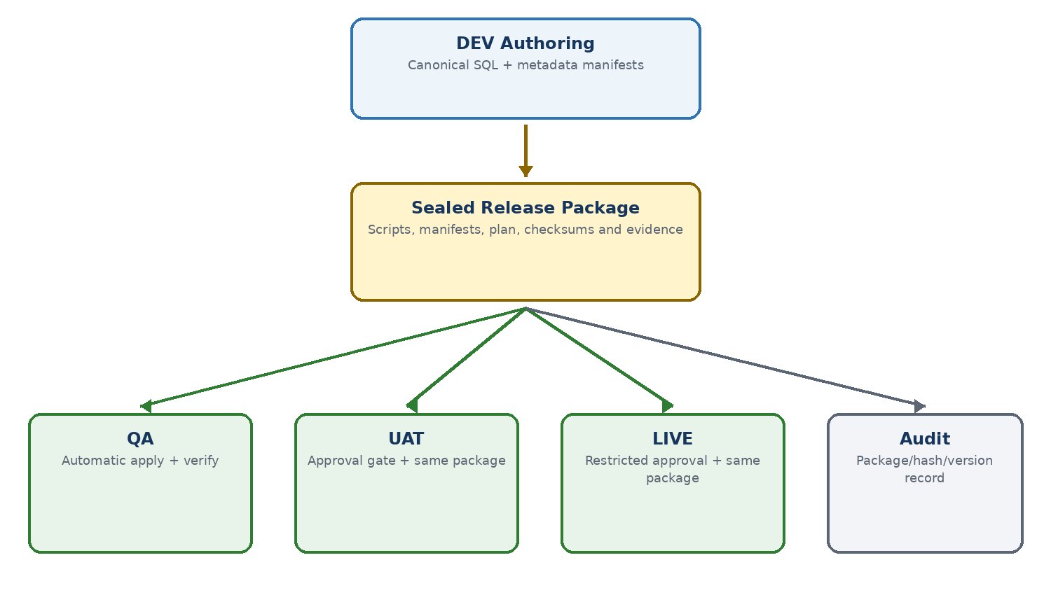
Figure 2. Generate once in DEV, seal once, apply unchanged to controlled targets.

8.1 Minimum package manifest
Field | Purpose
PackageId / Version | Stable release identity and ordering.
SourceCommit | Exact Git commit that produced the package.
ReleaseReference | Ticket, release or deployment identifier.
GeneratedUtc | Creation timestamp; never used as identity.
SchemaItems | Ordered files, object identities, source hashes and expected outcomes.
MetadataItems | Ordered stable GUID records, dependencies and desired-state hashes.
GeneratorVersion | Detects stale files when generation logic changes.
PackageSha256 | Seal over canonical package content.
ImageDigests | Links database package to immutable application containers.

8.2 Target package ledger
• Record package ID, version, SHA-256, source commit, release reference and environment.
• Record every attempt with execution ID, start/end time, actor/service identity and result.
• Reject the same package ID with a different hash.
• Treat an already successfully applied identical package as an idempotent no-op after verification.
• Retain preflight, preview, drift, deployment, recovery and post-verification evidence under one correlation ID.

9. Environment controls and security
Logical environment | SOCOTEC placement | Expected control
DEV | Developer workstation/local database | Authoring, comparison and package generation; developer-controlled.
QA | SOCOTEC DEV cluster/database | Automatic pipeline deployment after build and disposable-DB validation.
UAT | SOCOTEC UAT | Same package; protected approval and service-account execution.
LIVE | SOCOTEC production | Same package; restricted approval, least privilege, lock, audit and recovery evidence.

9.1 Security model
• Pipeline/service accounts receive only required EXECUTE and DDL permissions; developers do not require permanent LIVE write access.
• Connection strings and credentials come from approved secret storage and are never embedded in the package or logs.
• The runner validates target server/database identity and requires an explicit LIVE override/approval contract.
• One environment-specific application lock prevents concurrent apply operations to the same database.
• The browser displays commands and status but never receives SQL credentials.

10. Failure handling and recovery
Failure point | Required response
Source verification | Stop before target connection or modification; regenerate/review source in DEV.
Target drift | Stop before preparation; create and review a fresh comparison.
Preflight | Stop without schema mutation; correct data eligibility or package design.
After preparation | Run SCore.PostDeploymentScript recovery before returning the original error.
Object deployment | Record failed attempt and exact object/batch; do not continue silently.
Pre-post verification | Fail closed, retain expected/observed hashes, then restore lifecycle state.
Post-deployment lifecycle | Fail overall deployment; retain issue rows and verification evidence.
Metadata apply | Rollback transactional unit where possible; record per-record issue and never mark package applied.

Retry rule: A failed run may be retried only when the runner explicitly proves the accepted plan and target baseline are unchanged. Partially applied or obsolete comparisons should be retired and replaced with a fresh run.

11. Future CI/CD pipeline
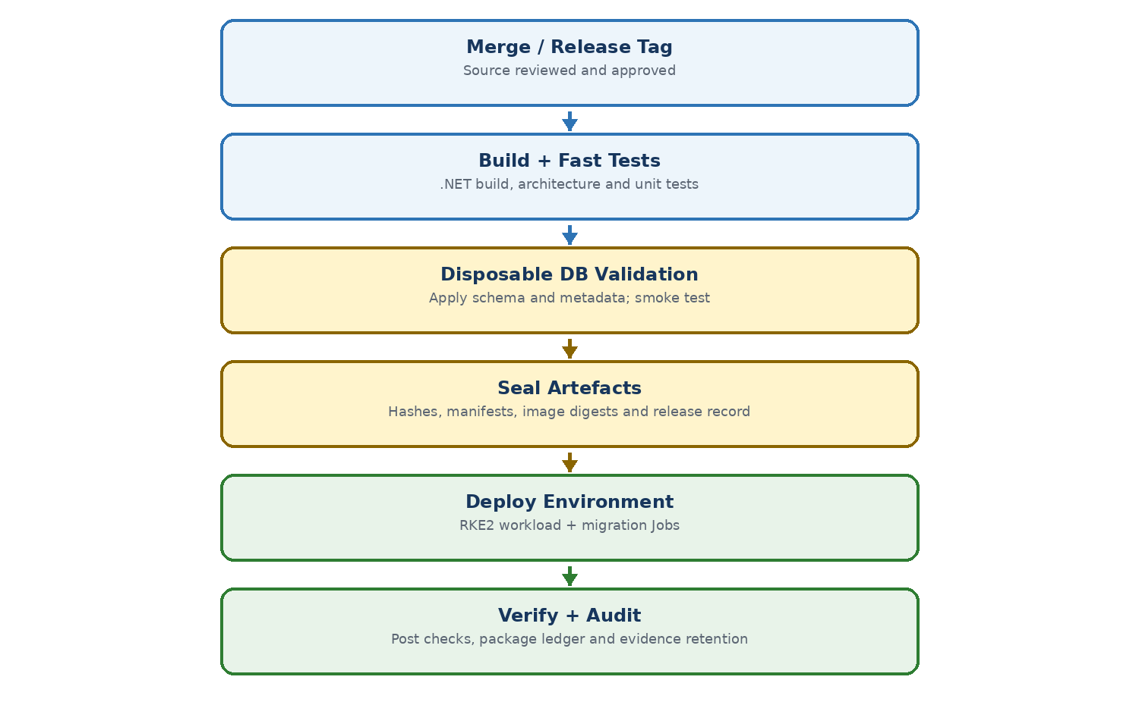
Figure 3. Target Bitbucket Pipelines and RKE2 database-delivery sequence.

11.1 Build and validation
1. A reviewed merge or release tag starts Bitbucket Pipelines.
2. Build the .NET solution and run fast, architecture, focused integration and policy tests.
3. Build PWA, API and worker container images once using Podman-compatible OCI tooling; push to the internal registry.
4. Restore a disposable SQL Server database from an approved baseline.
5. Apply the candidate schema package, apply metadata, run lifecycle restoration and execute database smoke/integration tests.
6. Produce a release manifest containing package hash and immutable container image digests.
7. Sign or otherwise seal the release artefacts and retain validation evidence.

11.2 Environment promotion
Stage | Gate | Action
QA | Automatic | Deploy images by digest; run schema Job; run metadata Job; verify and publish evidence.
UAT | Approval | Promote the identical digests/package; reject regeneration; execute and verify with UAT service identity.
LIVE | Restricted approval | Promote identical artefacts; enforce maintenance/approval policy, target lock, verification and audit.

11.3 RKE2 execution model
• Application components run as stateless Deployments; stateful SQL Server remains external unless separately designed.
• Schema and metadata migration execute as short-lived Kubernetes Jobs using the sealed package mounted or downloaded by immutable reference.
• Jobs use environment-specific secrets and service accounts while the package content remains identical.
• Deployment success requires both application health and database package verification.
• Use immutable image digests and release-specific tags; never use latest for QA, UAT or LIVE promotion.

12. Current versus target responsibilities
Responsibility | Current transitional model | Target automated model
Compare | Developer initiates through UI. | DEV release preparation or controlled pipeline task.
Selection | Developer reviews and saves UI selection. | Persisted release policy/selection reviewed in pull request.
Source generation | Developer runs -SyncSource. | Generated once by a controlled DEV packaging job; committed/reviewed or emitted as sealed artefact.
Tests | Developer runs fast tests locally. | Mandatory pipeline tests plus disposable database validation.
Apply | Operator runs PowerShell commands. | Environment-specific Kubernetes Job consumes the sealed package.
Approval | Recorded in UI/release process. | Bitbucket deployment environments plus retained approver identity.
Audit | SMigration tables and artifact folder. | Central release evidence plus per-database package ledger.
Recovery | Runner invokes post-deployment recovery. | Same runner/library in Jobs with evidence uploaded automatically.

13. Operating procedures

13.1 Developer creates a standard release
1. Implement canonical SQL and metadata-manifest changes in the feature branch.
2. Run local tests and review the Git diff.
3. Create a fresh DEV-authoritative run in the UI and compare against QA.
4. Save only intentional rows, validate and accept the release plan.
5. Run -SyncSource and review every generated file, including prepare/preflight/apply behaviour.
6. Commit the generated source and rerun tests.
7. Run -VerifySource and -WhatIf.
8. During transition, run -Apply to QA; in the target state, allow the pipeline Job to apply the sealed package.
9. Verify audit evidence and perform a fresh comparison only as a diagnostic convergence check, not to regenerate the package.

13.2 Promotion to UAT and LIVE
1. Select the already sealed release package and immutable application image digests.
2. Confirm the earlier environment succeeded and package hashes match.
3. Obtain the required environment approval.
4. Apply schema package, then metadata package, using the target service identity.
5. Verify object/record hashes and lifecycle state.
6. Record package ledger and publish evidence.
7. Do not regenerate scripts from QA or UAT.

13.3 Metadata-only onboarding release
1. Capture the approved UAT onboarding scope into stable-GUID manifests.
2. Validate duplicates, references and dependency order.
3. Generate and accept a metadata-only preview.
4. Seal the onboarding package independently of the standard schema release.
5. Apply idempotently to LIVE after business and production approval.
6. Verify by GUID and retain the onboarding audit record.

14. Acceptance criteria and roadmap

14.1 Production-readiness acceptance criteria
Criterion | Required proof
Package identity | A package hash changes for any SQL, manifest, ordering or generator change.
Immutable promotion | The same package hash is recorded in QA, UAT and LIVE.
Schema convergence | Every selected object matches the canonical expected hash after lifecycle restoration.
Metadata convergence | Every selected GUID matches desired state and a repeat apply is a no-op.
Drift protection | Changed target state stops deployment before mutation.
Recovery | Any failure after preparation attempts lifecycle restoration and retains both original and recovery evidence.
Security | UI has no SQL access; Jobs use least-privilege environment identities.
Audit | Release, package, approval, attempt and verification can be reconstructed without relying on console history.
End-to-end proof | Fresh DEV→QA, QA→UAT and approved LIVE rehearsal paths pass with no manual database correction.

14.2 Delivery roadmap
Phase | Outcome
1. Stabilise | Complete schema runner hardening and prove clean DEV→QA then QA→UAT using fresh runs.
2. Package | Formalise package manifest, generator version, checksums and per-database ledger.
3. Metadata authority | Complete stable-GUID source manifests and deterministic metadata package generation.
4. Disposable validation | Automate clean database restore, schema/metadata apply and integration tests.
5. Pipeline execution | Add Bitbucket steps and RKE2 migration Jobs using internal registry artefacts.
6. Protected promotion | Add UAT/LIVE approvals, secrets, evidence retention and operational runbooks.
7. Onboarding | Deliver independent UAT→LIVE metadata-only onboarding package flow.

Appendix A. PowerShell runner reference
This appendix describes the parameter surface present in tools/SchemaDeployment/Invoke-CymBuildSchemaDeployment.ps1 as reviewed on 8 September 2026. Commands generated by the UI must use the selected run’s exact target and release reference. Before relying on this appendix after a code change, compare it with Get-Help and the script parameter block in the release commit.

A.1 Discover the installed command surface
Show full help
Get-Help .\tools\SchemaDeployment\Invoke-CymBuildSchemaDeployment.ps1 -Full
Show invocation syntax
Get-Command .\tools\SchemaDeployment\Invoke-CymBuildSchemaDeployment.ps1 -Syntax
List parameter names
(Get-Command .\tools\SchemaDeployment\Invoke-CymBuildSchemaDeployment.ps1).Parameters.Keys | Sort-Object

A.2 Required identity and connection parameters
Parameter | Purpose and rules
-TargetServer | Required SQL Server/instance requested by the operator. The opened connection and accepted run target are checked unless an approved alias exception is used.
-TargetDatabase | Required target database. Must match the accepted run target; DEV is treated specially for diagnostic and post-deployment rules.
-RunGuid | Required SMigration run identity. It binds the invocation to the persisted comparison, selection, review and target baseline.
-ReleaseReference | Human-readable release/ticket identifier written into run and evidence context.
-DeploymentReference | Execution/deployment correlation value. Defaults to ReleaseReference, or to ManualSchemaDeployment-<RunGuid> when both are blank.
-RepoRoot | Repository root containing canonical Database/CymBuild_DB/Schema files. Defaults to the repository resolved from the script location.
-ConnectionString | Optional complete connection string. When supplied it takes precedence over the connection assembled from server, database and credentials.
-SqlUsername / -SqlPassword | Optional SQL authentication. Password is a SecureString and is mandatory when SqlUsername is supplied. Otherwise integrated security is used.

A.3 Execution modes
Mode | Behaviour | Mutates target?
Default / -WhatIf | Resolve the accepted plan, verify committed source, re-snapshot selected target objects and run read-only eligibility/preflight checks. If no mode switch is supplied, WhatIf is selected automatically. | No
-SyncSource | Write deterministic canonical SQL only for selected objects from an accepted source run; produce source-sync-manifest.json; return before target preflight/deployment. | No; writes repository files
-VerifySource | Verify selected source files are tracked, committed, unchanged and fresh for the current generator. It implicitly disables source materialisation. | No
-Apply | Acquire the database application lock, repeat drift/preflight checks, run lifecycle preparation, deploy the complete supported selection, verify, restore and audit. | Yes

A.4 Safety, override and recovery switches
Switch | What it permits | Hard boundary / required use
-AllowPartial | Allows WhatIf/resolution to continue when unsupported selected rows exist so supported and unsupported evidence can be inspected. | Cannot be combined with Apply, SyncSource or VerifySource. It never authorises a partial deployment.
-AllowLive | Permits -Apply when target naming is classified as LIVE/production. | Use only after the approved LIVE gate. It does not bypass acceptance, source integrity, drift, preflight, lock, lifecycle or verification.
-AllowNonDevSource | Allows SyncSource or VerifySource when the accepted run does not record exactly DEV / CymBuild_Dev. | Only valid with SyncSource or VerifySource. It relaxes only source-environment identity and requires enhanced review.
-IgnoreTargetMismatch | Accepts a deliberately equivalent server/database alias when the requested/opened target text differs from the run. | Alias exception only. It must not be used to redirect a package to a different logical environment and does not disable target drift checks.
-SkipAcceptanceCheck | Bypasses reviewed/accepted run-state enforcement for diagnostics. | Apply use is restricted by code to a DEV target. Invalid with SyncSource or VerifySource; never use for QA, UAT or LIVE promotion.
-RetryFailedDeployment | Allows an unchanged reviewed run whose status is DeploymentFailed to resume under retry-aware baseline checks. | Inspect prior evidence first. Invalid with SyncSource/VerifySource and cannot be combined with pre/post lifecycle skips.
-SkipPreDeployment | Skips SCore.PreDeploymentScript for a diagnostic invocation. | QA, UAT and later Apply operations are refused. Never use for a controlled promotion.
-SkipPostDeployment | Skips SCore.PostDeploymentScript for a diagnostic invocation. | QA, UAT and later Apply operations are refused. Never use for a controlled promotion.
-SkipSourceMaterialization | Prevents any source materialisation path. VerifySource turns it on automatically. | Cannot be combined with SyncSource, which must write selected repository artefacts.

A.5 Operational options
Parameter | Purpose | Default / constraint
-ApplyLockTimeoutSeconds | How long Apply waits for the database-scoped application lock before failing. | 0 seconds; integer range 0 to 2,147,483.
-OutputDirectory | Overrides the evidence output location for the invocation. | artifacts/schema-deployment/<RunGuid>/executions/<ExecutionId> under RepoRoot.

A.6 Compatibility matrix
Combination | Supported? | Reason
-Apply + -WhatIf | No | Execution modes are mutually exclusive.
-Apply + -AllowPartial | No | Apply requires the complete accepted selected plan.
-SyncSource + -VerifySource | No | Source write and source verification are distinct modes.
Sync/Verify + -WhatIf or -Apply | No | Source modes return before target preflight/deployment.
Sync/Verify + partial/acceptance-skip/retry | No | Source modes require the complete accepted selection.
-SyncSource + -SkipSourceMaterialization | No | SyncSource must be allowed to write canonical files.
-AllowNonDevSource without Sync/Verify | No | The switch has no valid effect outside source modes.
-RetryFailedDeployment + lifecycle skip | No | Retry must prepare and restore the full lifecycle.
QA/UAT/LIVE Apply + lifecycle skip | No | Later environments must execute the complete lifecycle.
LIVE-looking target + -Apply + -AllowLive | Yes, gated | Still requires all other checks and approved production procedure.

Deliberate limitation: There is no supported switch to ignore target drift, suppress unique-index duplicate failures, apply unsupported rows, or mark a failed verification as successful. Correct the plan/data or create a fresh reviewed run.

A.7 Standard command sequence
Values below are placeholders. The normal flow should be exposed in Deploy & Audit as copyable commands. Exceptional switches should appear only in a collapsed, role-controlled panel with a reason field and a warning that the command is outside the ordinary promotion path.
Generate canonical source
.\tools\SchemaDeployment\Invoke-CymBuildSchemaDeployment.ps1 `
-TargetServer '<server>' `
-TargetDatabase '<database>' `
-RunGuid '<guid>' `
-SyncSource
Run fast tests
.\tools\Testing\Invoke-CymBuildFastTests.ps1
Verify committed source
.\tools\SchemaDeployment\Invoke-CymBuildSchemaDeployment.ps1 `
-TargetServer '<server>' `
-TargetDatabase '<database>' `
-RunGuid '<guid>' `
-VerifySource
Dry run
.\tools\SchemaDeployment\Invoke-CymBuildSchemaDeployment.ps1 `
-TargetServer '<server>' `
-TargetDatabase '<database>' `
-RunGuid '<guid>' `
-ReleaseReference '<release>' `
-WhatIf
Apply
.\tools\SchemaDeployment\Invoke-CymBuildSchemaDeployment.ps1 `
-TargetServer '<server>' `
-TargetDatabase '<database>' `
-RunGuid '<guid>' `
-ReleaseReference '<release>' `
-Apply

A.8 Controlled exception examples
Approved LIVE apply
.\tools\SchemaDeployment\Invoke-CymBuildSchemaDeployment.ps1 `
-TargetServer '<live-server>' `
-TargetDatabase '<live-database>' `
-RunGuid '<guid>' `
-ReleaseReference '<release>' `
-AllowLive `
-Apply
Verify a deliberate non-DEV reconciliation source
.\tools\SchemaDeployment\Invoke-CymBuildSchemaDeployment.ps1 `
-TargetServer '<server>' `
-TargetDatabase '<database>' `
-RunGuid '<guid>' `
-AllowNonDevSource `
-VerifySource
Inspect a plan containing unsupported rows
.\tools\SchemaDeployment\Invoke-CymBuildSchemaDeployment.ps1 `
-TargetServer '<server>' `
-TargetDatabase '<database>' `
-RunGuid '<guid>' `
-AllowPartial `
-WhatIf
Retry an unchanged failed deployment
.\tools\SchemaDeployment\Invoke-CymBuildSchemaDeployment.ps1 `
-TargetServer '<server>' `
-TargetDatabase '<database>' `
-RunGuid '<failed-guid>' `
-ReleaseReference '<release>' `
-RetryFailedDeployment `
-Apply
Approved equivalent target alias
.\tools\SchemaDeployment\Invoke-CymBuildSchemaDeployment.ps1 `
-TargetServer '<approved-alias>' `
-TargetDatabase '<equivalent-database-alias>' `
-RunGuid '<guid>' `
-IgnoreTargetMismatch `
-WhatIf

A.9 UI presentation requirements
• Show Sync Source, Fast Tests, Verify Source, WhatIf and Apply as the ordinary ordered workflow, with prerequisites and completion state.
• Generate commands from persisted target server, database, run GUID and release reference; never ask an operator to retype values that CymBuild already owns.
• Show AllowLive only for authorised LIVE releases and require an approval/reason reference before revealing the command.
• Keep all other overrides in an advanced diagnostics panel. Display the exact relaxation, prohibited combinations and environment restriction beside each switch.
• Never expose a one-click browser action that executes SQL. Commands remain copyable during transition; future CI/CD maps the same parameters to protected Jobs and secrets.
• Persist whether an override was used, its reason and the executing identity in the run evidence/package ledger.

Appendix B. Evidence and audit artefacts
Artefact | Purpose
deployment-plan.csv | Accepted plan rows and immutable selection context.
resolved-items.csv | Resolved source files, deployment modes and expected hashes.
unsupported-items.csv | Rows that could not be safely materialised or executed.
materialized-source-items.csv | Files written during DEV source synchronisation.
source-sync-manifest.json | Source generation inputs, outputs, hashes and repository context.
manual-preview-deployment.sql | Human-readable ordered preview; not an alternative manual promotion route.
pre-post-deployment-verification-failures.csv | Mismatch evidence after object deployment and before lifecycle restoration.
post-deployment-issues.csv | Lifecycle restoration warnings/errors correlated to the run and attempt.
summary.json | Execution mode, counts, release context, source commit, output paths and outcome.
Database package ledger | Persistent target record of package/version/hash and all execution attempts.

Document caveat
This document describes the approved target design and intended operating model as at 8 September 2026. Repository code, database bootstrap objects, permissions and pipeline definitions must be verified against the current branch before implementation or production use. Where current behaviour differs, the target principles in this document should drive a reviewed correction rather than a manual environment workaround.

